**Create an IAM Role**

**Step 1:** Creating an IAM role

* In the IAM panel, click on *Roles* -> *Create role*

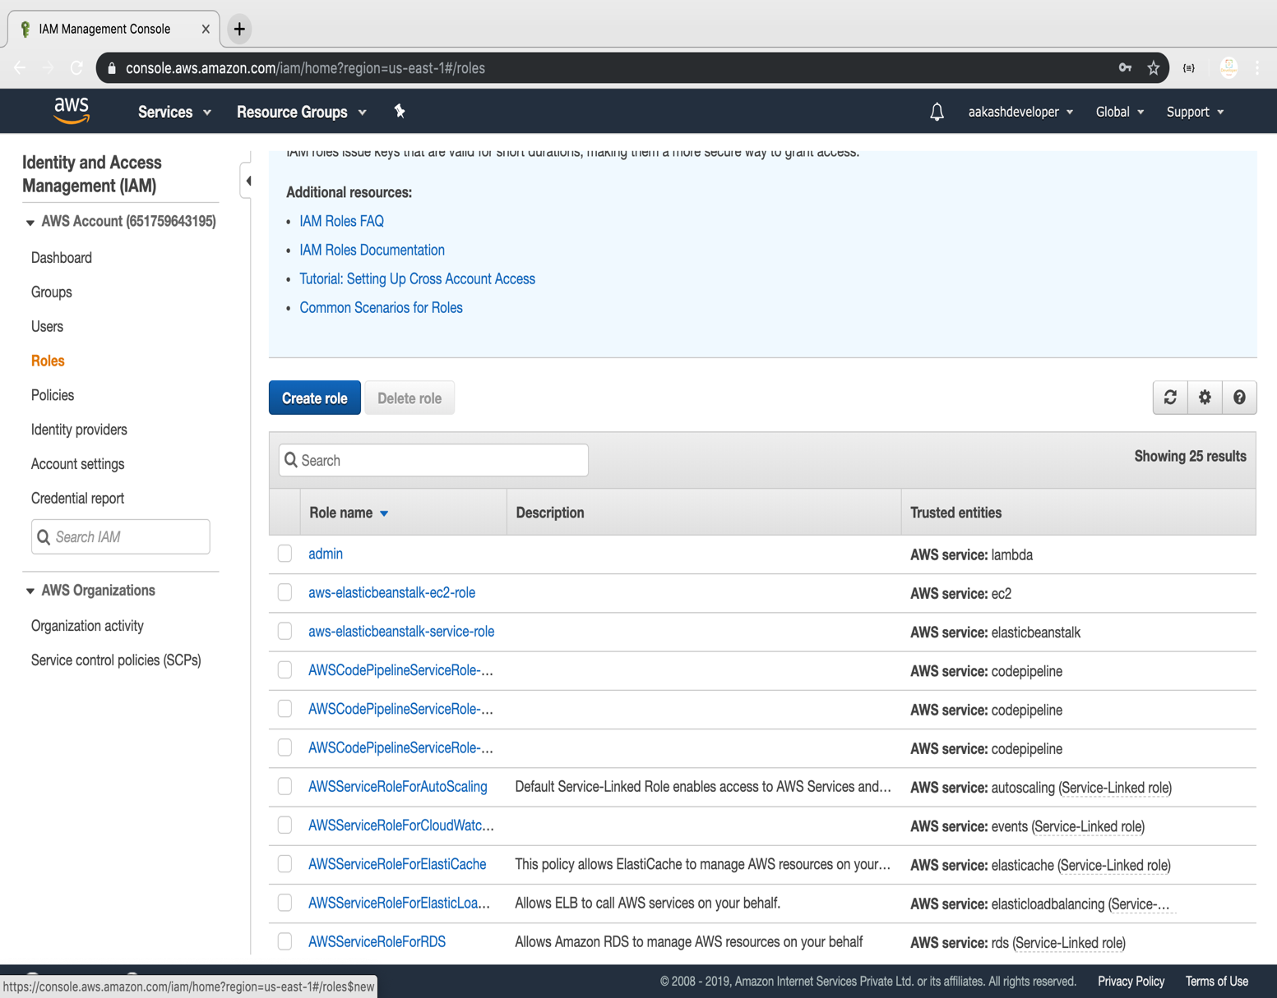

* Select the service

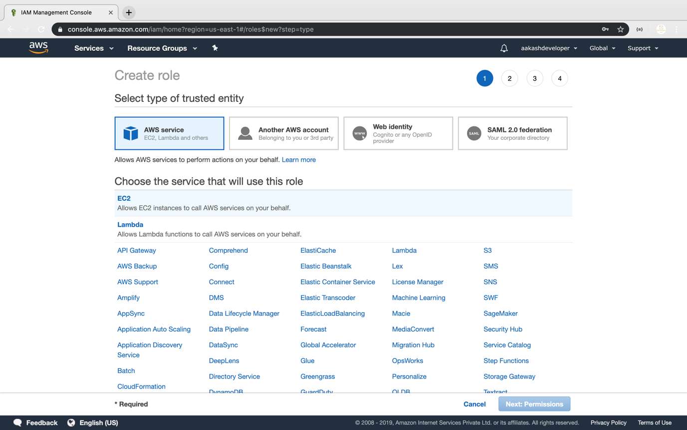

**Step 2:** Adding AWS policy to the role

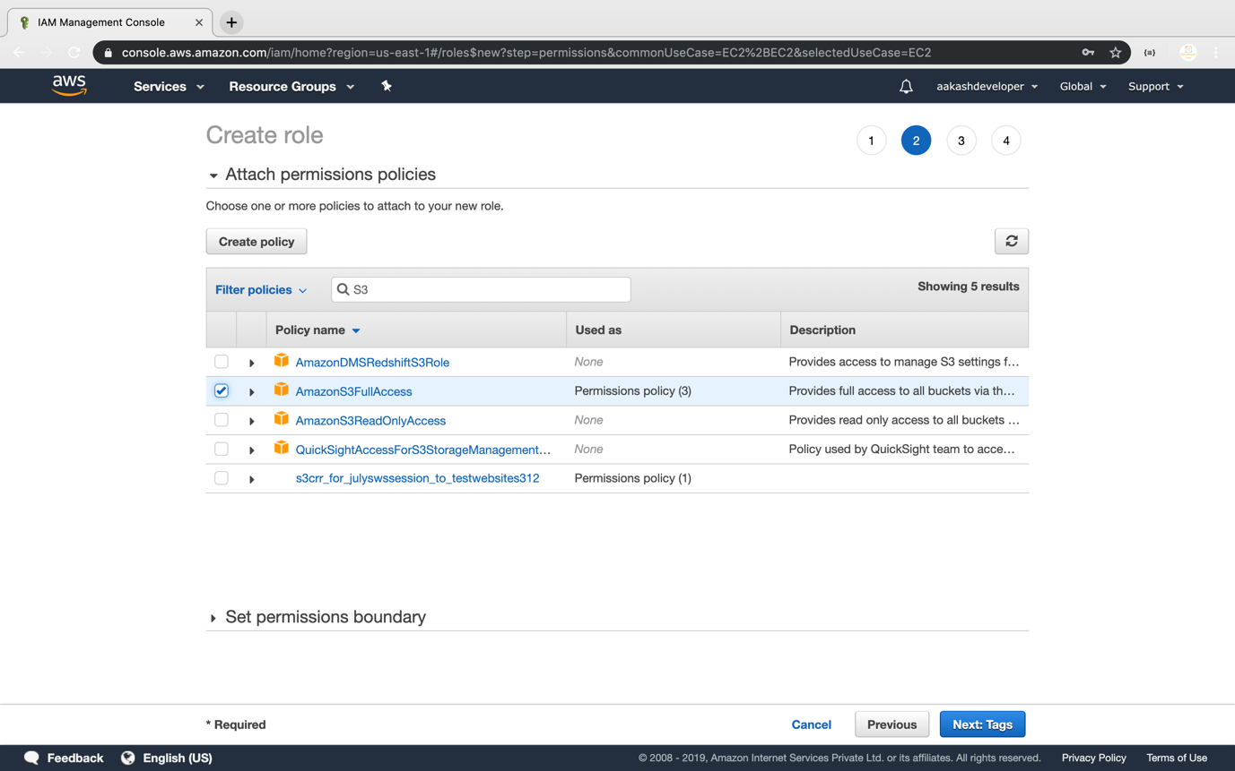

**Step 3:** Providing a key and a value for the role

* Add a key and a value to the role

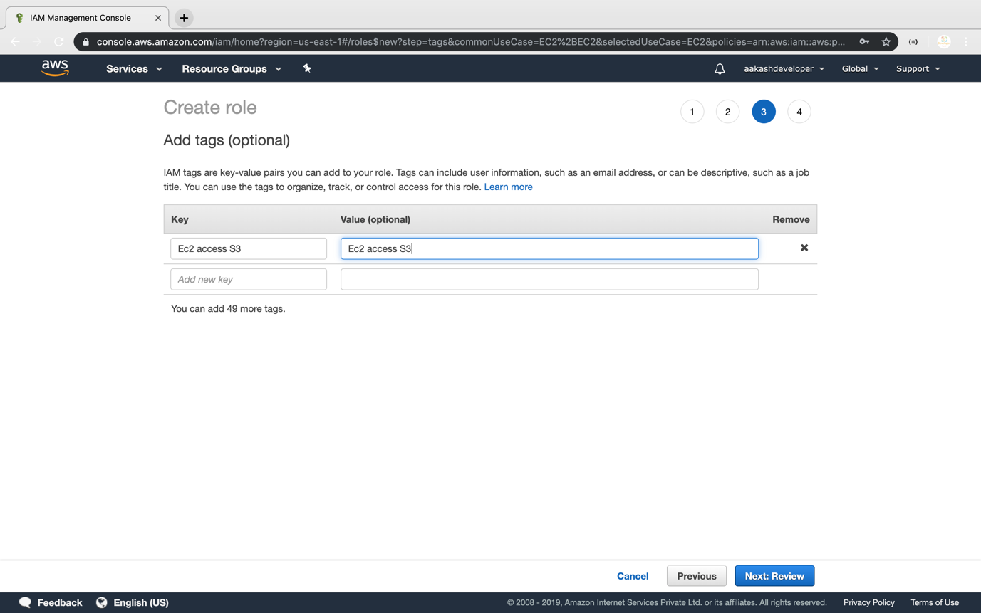

* Add a role:

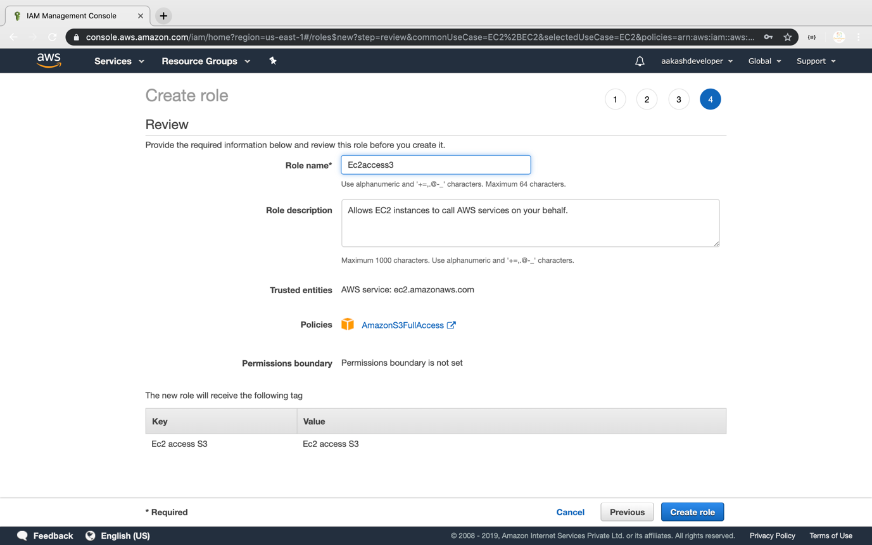

* Once the role is created, you can find it in the IAM panel

